**Banking System**

- Rehana Sulthana Mohammed

**Task:1. Database Design**

**1. Create the database named "HMBank"**

create database HMBank;

**2. Define the schema for the Customers, Accounts, and Transactions tables based on the provided schema.**

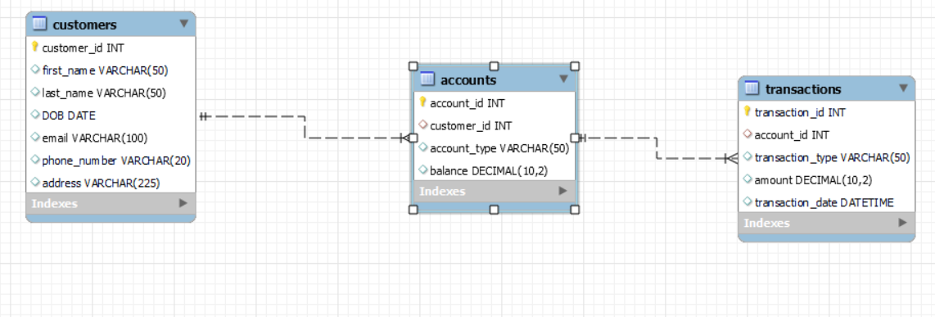

**3. Create an ERD (Entity Relationship Diagram) for the database.**

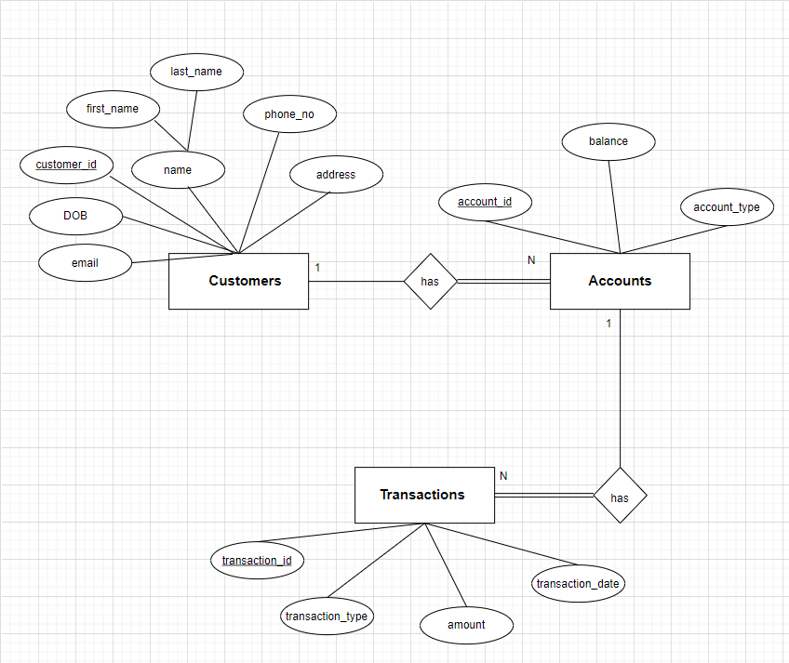

**4. Create appropriate Primary Key and Foreign Key constraints for referential integrity.**

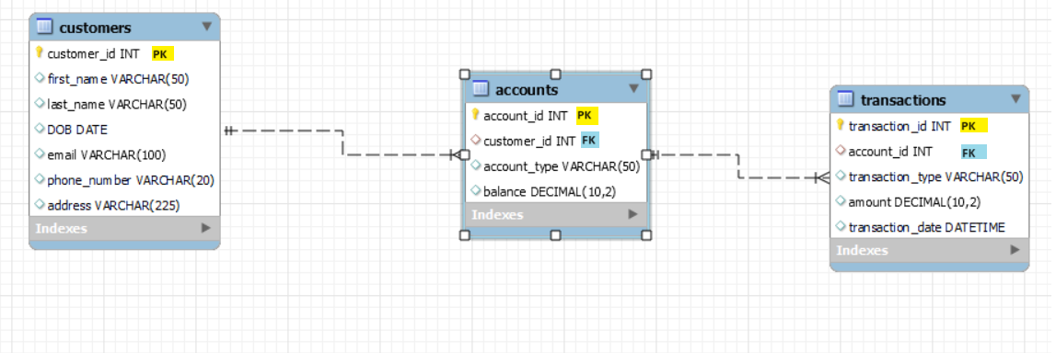

**5. Write SQL scripts to create the mentioned tables with appropriate data types, constraints, and relationships.**

**• Customers**

create table Customers (

customer_id int primary key,

first_name varchar(50),

last_name varchar(50),

DOB date,

email varchar(100),

phone_number varchar(20),

address varchar(225)

);

**• Accounts**

create table Accounts (

account_id int primary key,

customer_id int references customers(customer_id),

account_type varchar(50),

balance decimal(10,2)

);

**• Transactions**

create table Transactions (

transaction_id int Primary Key,

account_id int references accounts(account_id),

transaction_type varchar(50),

amount decimal(10,2),

transaction_date datetime

);

**Tasks 2: Select, Where, Between, AND, LIKE**

**1. Insert at least 10 sample records into each of the following tables. • Customers • Accounts • Transactions**

**Customers Table:**

Insert into Customers(customer_id,first_name,last_name,DOB,Email,phone_number,address)

values (1,'Abhi','N','2001-12-04','abhi@gmail.com','8801800231','Chennai'),

(2,'Bindhu','D','2001-06-04','bindhu@gmail.com','9032756701','Delhi'),

(3,'Aditya','M','2001-05-25','aditya@gmail.com','9849438723','Warangal'),

(4,'Dhanvi','A','2002-08-15','dhanvi@gmail.com','8019599862','Hyderabad'),

(5,'Pooja','M','2001-03-02','pooja@gmail.com','8309348045','Vizag'),

(6,'Vishnu','K','1998-10-11','vishnu@gmail.com','8805476041','Kadapa'),

(7,'Farooq','P','2001-12-04','farooq@gmail.com','9876800241','Nellore'),

(8,'Ravali','A','2001-12-31','ravali@gmail.com','7416216935','SR Nagar'),

(9,'Avyuktha','H','2000-11-27','avyuktha@gmail.com','9963774964','Australia'),

(10,'Raja','R','1999-10-14','raja@gmail.com','7894563210','Vijayawada');

**Accounts Table:**

Insert into Accounts (account_id,customer_id,account_type,balance)

values (101,5,'zero_balance','52042.54'),

(102,8,'savings','25000.54'),

(103,3,'zero_balance','75896.04'),

(104,9,'current','54880.49'),

(105,10,'zero_balance','80042.00'),

(106,6,'savings','152042.54'),

(107,2,'savings','98042.78'),

(108,7,'current','3202.13'),

(109,4,'zero_balance','60042.26'),

(110,1,'savings','10342.98');

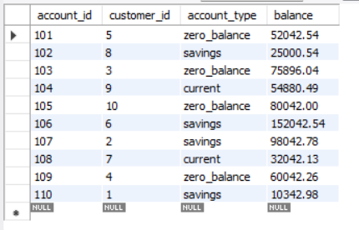

**Transactions Table:**

Insert into Transactions(transaction_id,account_id,transaction_type,amount,transaction_date)

values (201,110,'deposit','35000.00','2023-12-04 12:45:06'),

(202,101,'transfer','26000.00','2023-12-08 20:45:14'),

(203,109,'withdrawal','5000.00','2023-12-06 16:05:36'),

(204,102,'withdrawal','10000.00','2023-12-09 09:35:46'),

(205,108,'deposit','100000.00','2023-12-02 15:30:00'),

(206,103,'transfer','50000.00','2023-12-07 12:45:06'),

(207,107,'withdrawal','15000.00','2023-12-04 12:45:06'),

(208,108,'transfer','67000.00','2023-12-08 14:18:26'),

(209,106,'transfer','2500.00','2023-12-02 11:59:16'),

(210,105,'deposit','20000.00','2023-12-01 10:20:58');

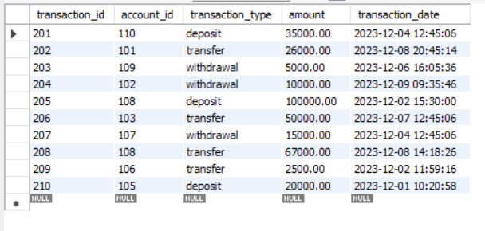

**2. Write SQL queries for the following tasks:**

**1. Write a SQL query to retrieve the name, account type and email of all customers.**

select first_name, last_name, account_type, email from Customers as c1, accounts as a1 where c1.customer_id = a1.customer_id;

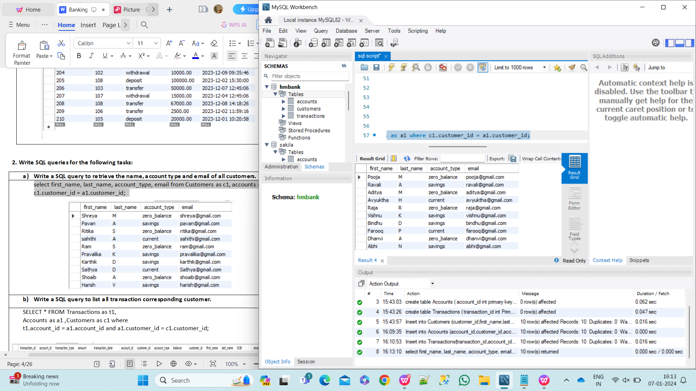

**2. Write a SQL query to list all transaction corresponding customer.**

select * from Transactions as t1, Accounts as a1 , Customers as c1 where

t1.account_id = a1.account_id and a1.customer_id = c1.customer_id;

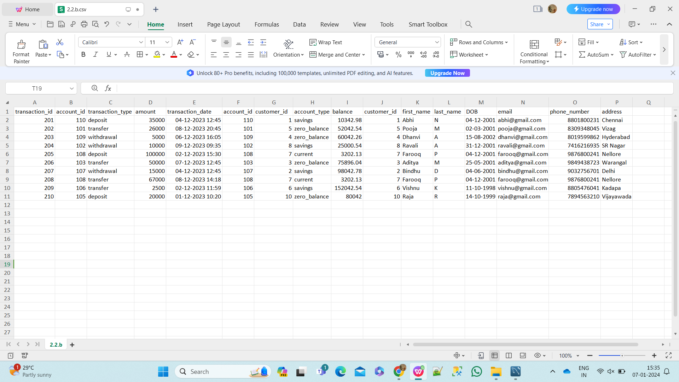

**3. Write a SQL query to increase the balance of a specific account by a certain amount.**

Update Accounts SET balance = balance + 2500.14 WHERE account_id = 109;

select * from accounts;

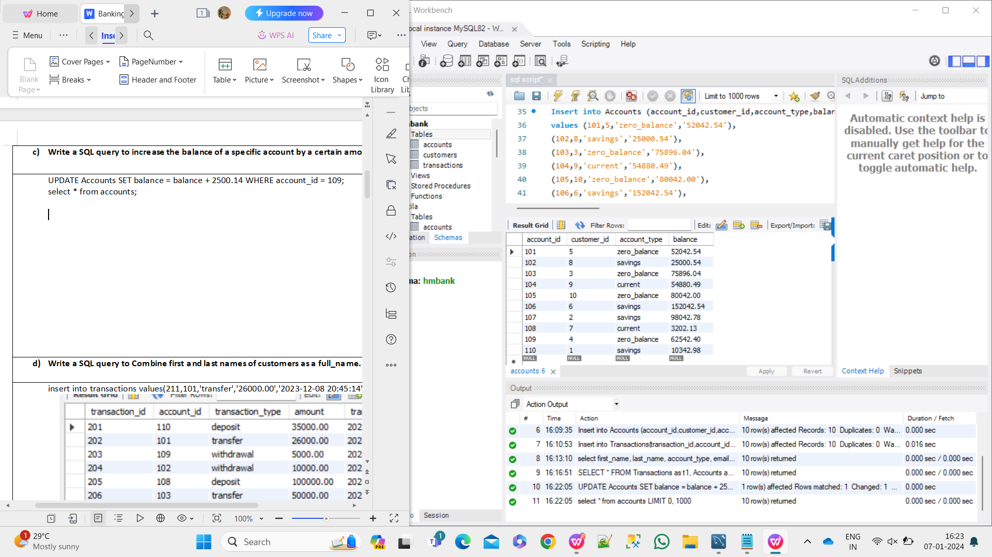

**4. Write a SQL query to Combine first and last names of customers as a full_name.**

select concat(first_name,last_name) as full_name from customers;

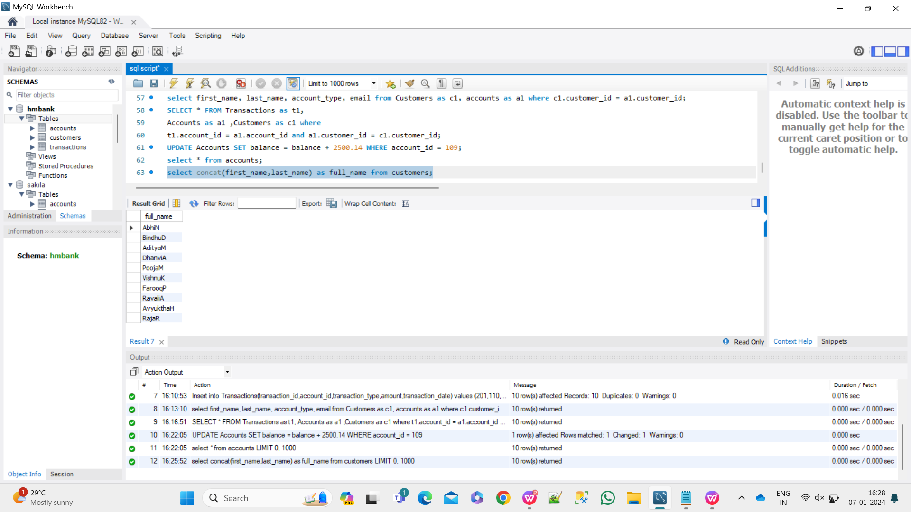

**5. Write a SQL query to remove accounts with a balance of zero where the account**

**type is savings.**

Insert into Accounts (account_id,customer_id,account_type,balance) values (111,15,'savings','0.00');

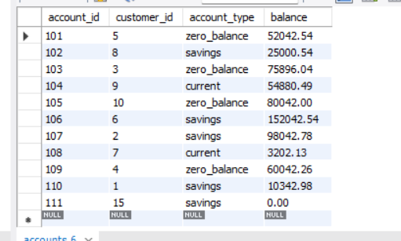

delete from accounts where balance=0 and account_type='savings';

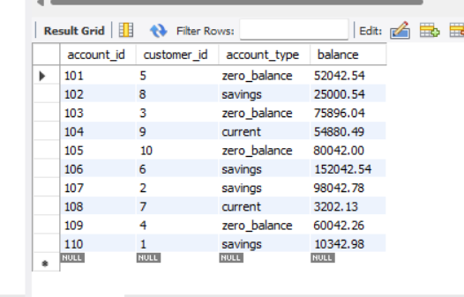

**6. Write a SQL query to Find customers living in a specific city.**

select * from customers where address = 'Vizag';

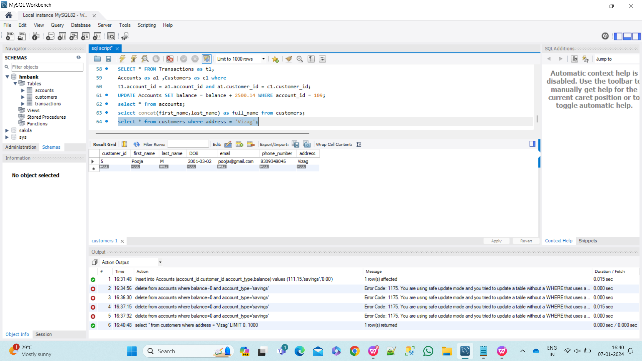

**7. Write a SQL query to Get the account balance for a specific account.**

Select balance from accounts where account_id = '104';

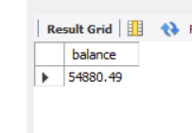

**8. Write a SQL query to List all current accounts with a balance greater than 50000.**

select * from accounts where account_type='current' and balance>50000;

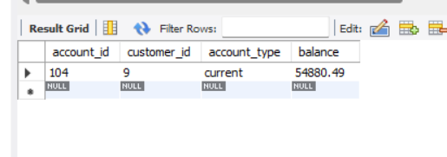

**9. Write a SQL query to Retrieve all transactions for a specific account.**

Select * from transactions as t1,accounts as a1 where a1.account_id = '108' and t1.account_id=a1.account_id;

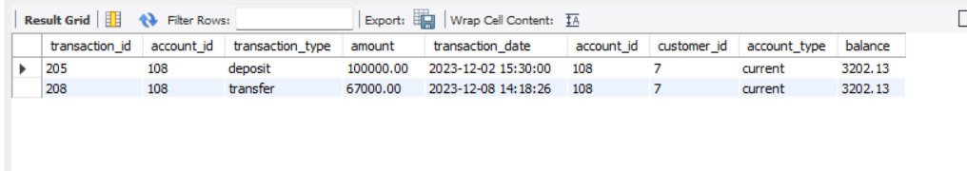**10.** **Write a SQL query to Calculate the interest accrued on savings accounts based on a**

**given interest rate.**

Select account_id,customer_id,account_type,balance,(balance/100)*4.5 as interest from accounts where account_type = 'savings';

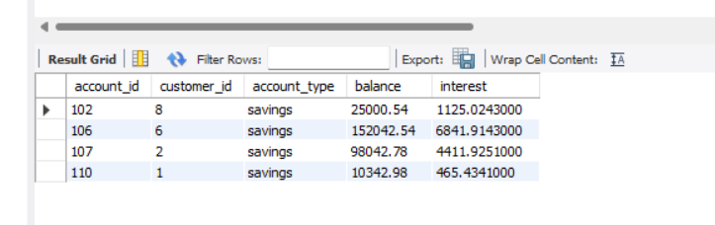

**11.** **Write a SQL query to Identify accounts where the balance is less than a specified**

**overdraft limit.**

Select account_id,balance,customer_id from accounts where balance<15000;

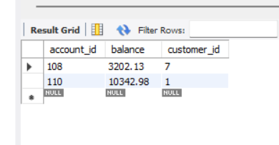

**12. Write a SQL query to Find customers not living in a specific city.**

Select * from customers where address <> 'Vijayawada';

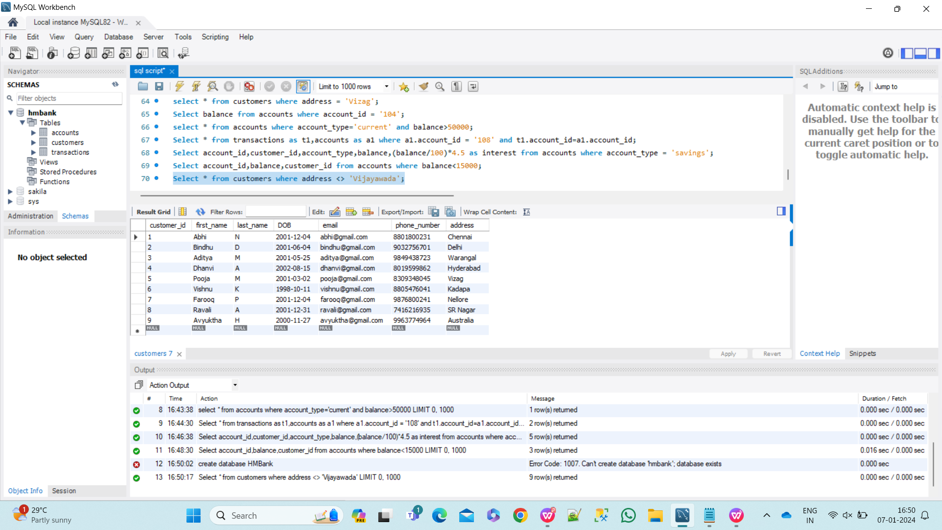

**Tasks 3: Aggregate functions, Having, Order By, GroupBy and Joins**

**1. Write a SQL query to Find the average account balance for all customers.**

Select avg(balance) as averageBalance from accounts;

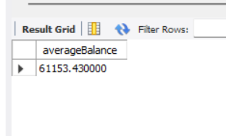

**2.** **Write a SQL query to Retrieve the top 10 highest account balances.**

Select account_id,balance from accounts order by balance desc limit 10;

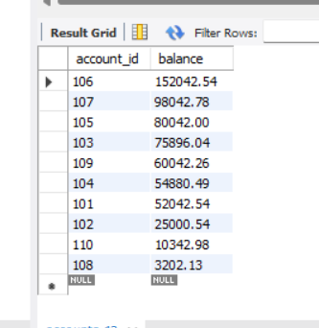

**3.** **Write a SQL query to Calculate Total Deposits for All Customers in specific date.**

SELECT c.customer_id,c.first_name,c.last_name,sum(a.balance) as toataldeposit from customers as c join accounts a on c.customer_id=a.customer_id join transactions as t on a.account_id=t.account_id where t.transaction_type='deposit' and date(t.transaction_date)='2023-12-04' group by c.customer_id,c.first_name,c.last_name;

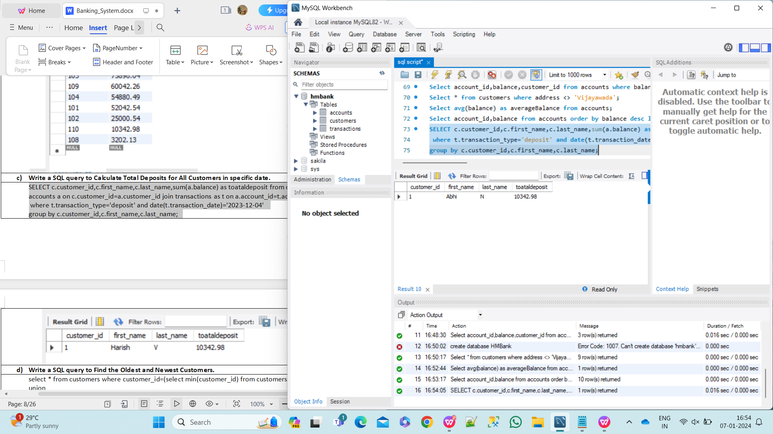

**4. Write a SQL query to Find the Oldest and Newest Customers.**

select * from customers where customer_id=(select min(customer_id) from customers) union select * from customers where customer_id=(select max(customer_id) from customers);

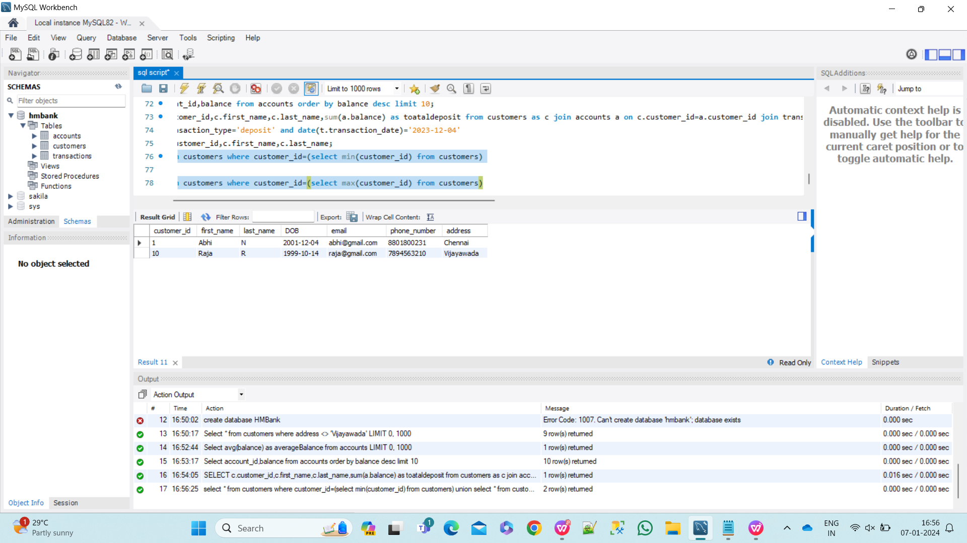

**5. Write a SQL query to Retrieve transaction details along with the account type.**

Select a.account_id, a.account_type, t.transaction_id ,t.transaction_type, t.amount, t.transaction_date from accounts as a natural join transactions as t;

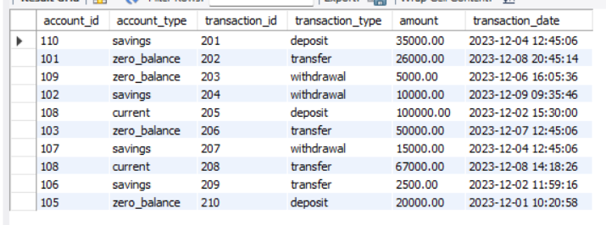

**6. Write a SQL query to Get a list of customers along with their account details.**

Select * from customers as c natural join accounts as a;

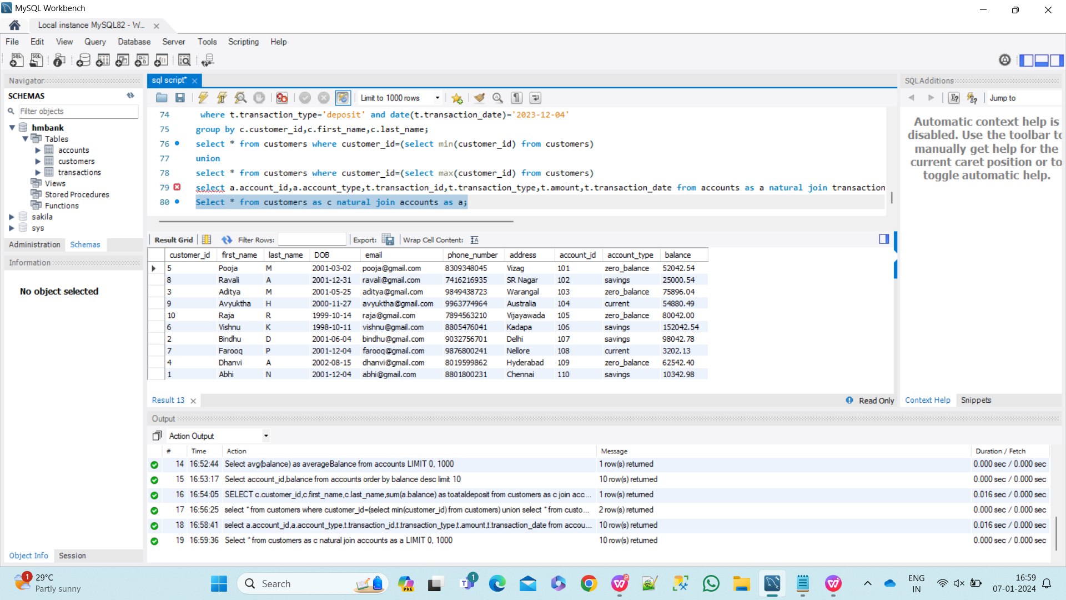

**7.** **Write a SQL query to Retrieve transaction details along with customer information for a**

**specific account.**

Select c.customer_id, c.first_name, c.last_name, c.dob, c.email, c.phone_number, c.address, t.transaction_id, t.transaction_date, t.amount, t.transaction_type from customers as c natural join accounts as a natural join transactions as t;

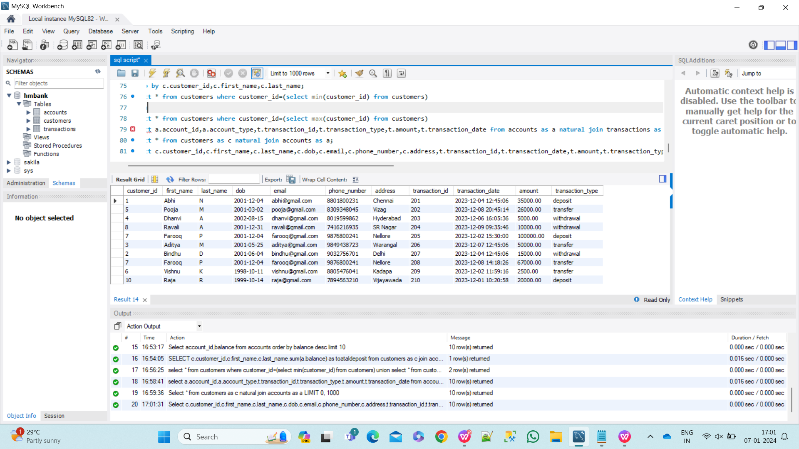

**8. Write a SQL query to Identify customers who have more than one account.**

insert into accounts values(111,5,'savings',100000.00);

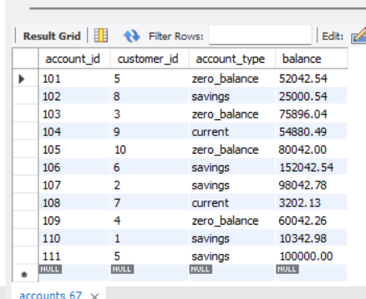

Select c.customer_id,c.first_name,c.last_name,count(a.account_id) as numberofaccounts from customers as c natural join accounts as a group by c.customer_id having count(a.customer_id)>1;

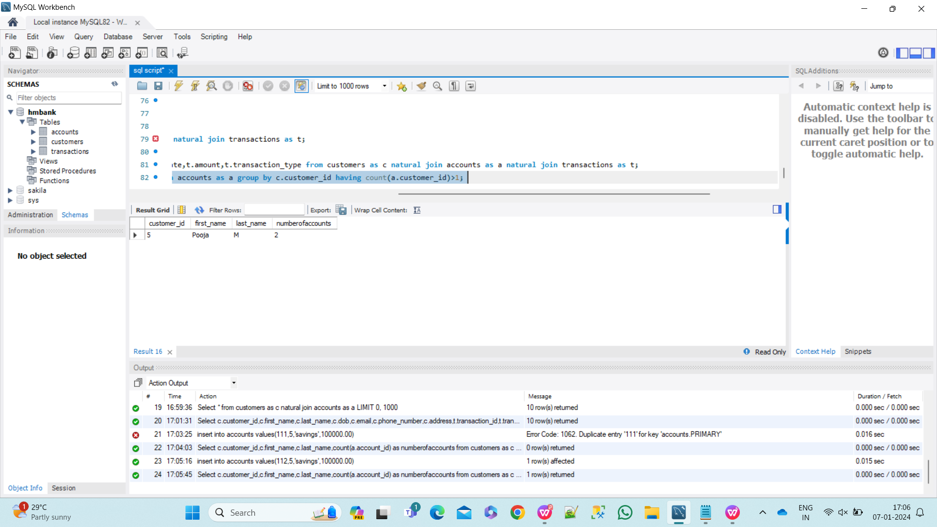

**9.Write a SQL query to Calculate the difference in transaction amounts between deposits and** **withdrawals.**

SELECT account_id, SUM(CASE WHEN transaction_type = 'deposit' THEN amount ELSE 0 END) AS total_deposits, SUM(CASE WHEN transaction_type = 'withdrawal' THEN amount ELSE 0 END) AS total_withdrawals, SUM(CASE WHEN transaction_type = 'deposit' THEN amount ELSE -amount END) AS difference FROM Transactions GROUP BY account_id;

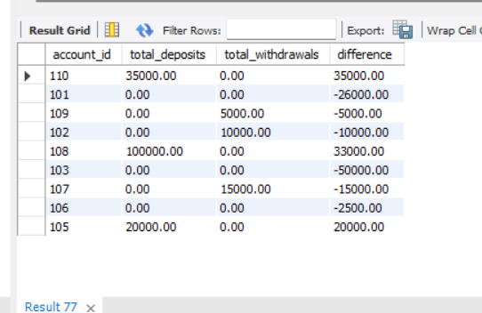

**10.Write a SQL query to Calculate the average daily balance for each account over a specified period.**

SELECT account_id, AVG(balance) AS average_daily_balance FROM Accounts WHERE account_id IN (SELECT DISTINCT account_id FROM Transactions WHERE transaction_date BETWEEN date('2023-12-04') AND date('2023-12-08') ) GROUP BY account_id;

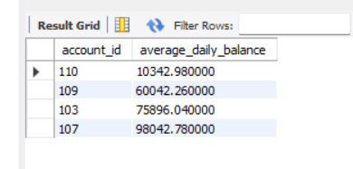

**11. Calculate the total balance for each account type.**

select account_type,sum(balance) as Total_balance from accounts group by account_type;

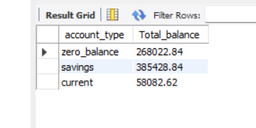

**12. Identify accounts with the highest number of transactions order by descending order.**

select account_id from transactions group by account_id order by count(transaction_id) desc;

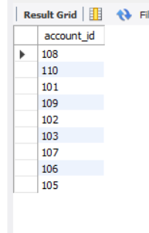

**13. List customers with high aggregate account balances, along with their account types.**

SELECT c.customer_id, c.first_name, c.last_name, a.account_type, a.balance

FROM Customers c

NATURAL JOIN accounts a

WHERE a.balance >= 50000;

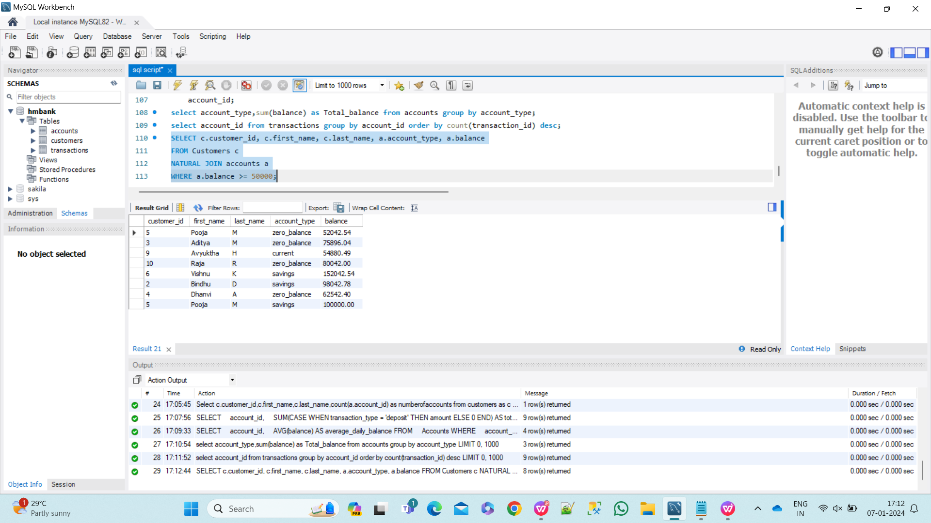

**14. Identify and list duplicate transactions based on transaction amount, date, and account.**

insert into transactions values(211,101,'transfer','26000.00','2023-12-08 20:45:14');

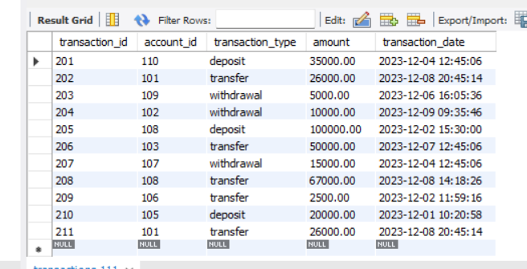

SELECT * FROM transactions t1

JOIN transactions t2 ON t1.amount = t2.amount

AND t1.transaction_date = t2.transaction_date

AND t1.account_id = t2.account_id

AND t1.transaction_id <> t2.transaction_id

ORDER BY t1.account_id, t1.transaction_id;

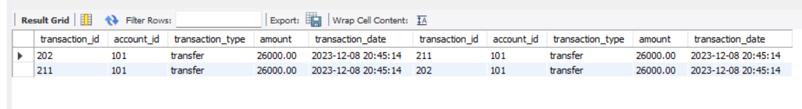

**Tasks 4: Subquery and its type**

**1. Retrieve the customer(s) with the highest account balance.**

select * from customers where customer_id=(select customer_id from accounts

where balance=(select max(balance) from accounts));

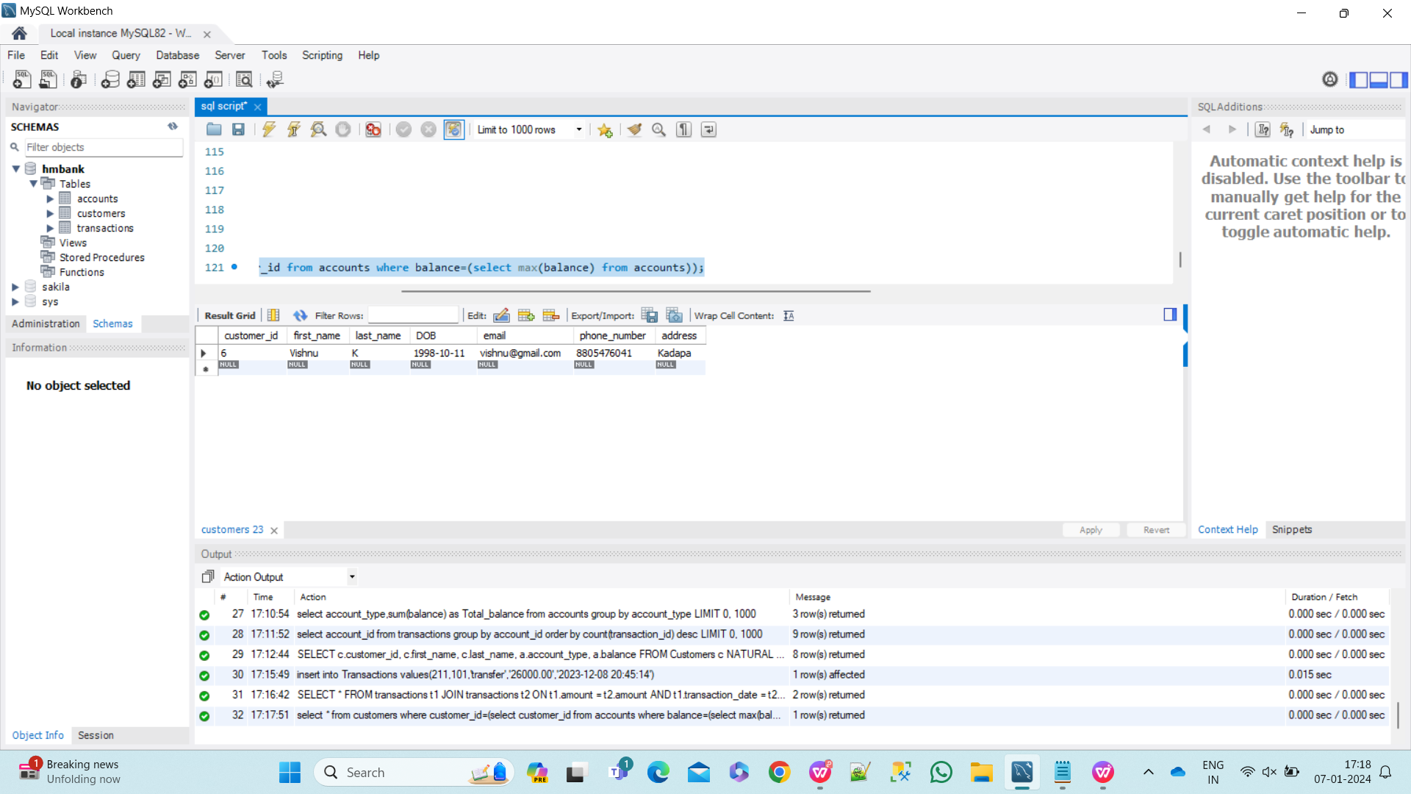

**2. Calculate the average account balance for customers who have more than one account.**

select c.customer_id,c.first_name,c.last_name,avg(a.balance) as average_balace from customers as c natural join accounts as a

where c.customer_id in(select customer_id from accounts group by customer_id having count(account_id)>1)

group by c.customer_id,c.first_name,c.last_name;

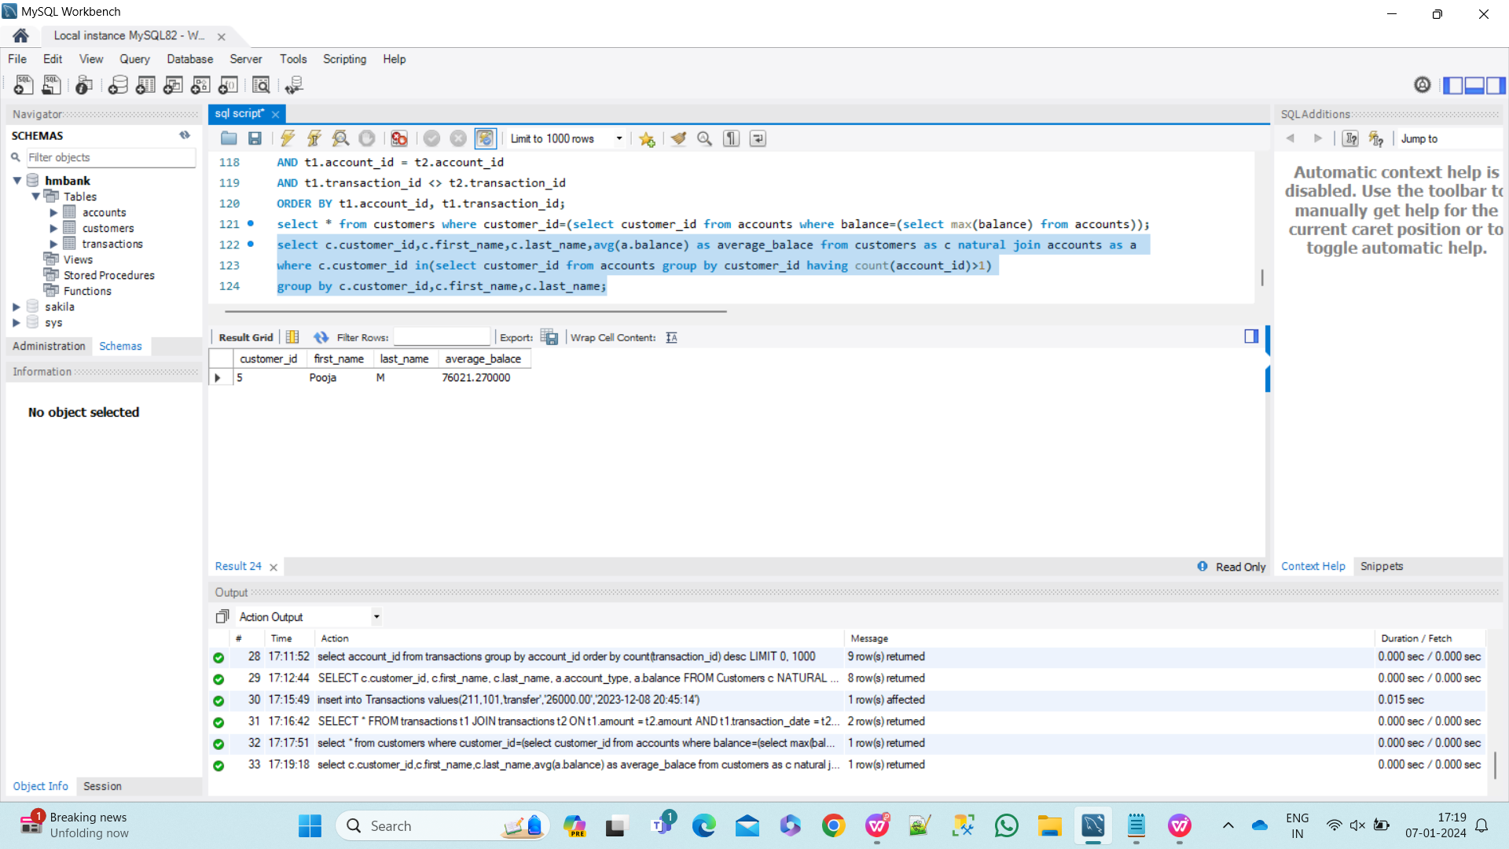

**3. Retrieve accounts with transactions whose amounts exceed the average transaction amount.**

select a.account_id,t.transaction_id,t.transaction_type,t.transaction_date,t.amount from accounts as a natural join transactions as t where t.amount>(select avg(amount) from transactions);

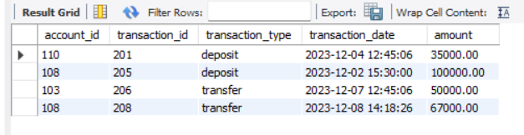

**4. Identify customers who have no recorded transactions.**

select customer_id from customers where customer_id not in (select c.customer_id from customers as c natural join accounts as a natural join transactions as t);

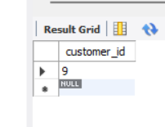

**5. Calculate the total balance of accounts with no recorded transactions.**

select a1.account_id,a1.balance from customers as c1 natural join accounts as a1

where customer_id not in (select c.customer_id from customers as c natural join accounts as a natural join transactions as t);

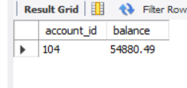

**6. Retrieve transactions for accounts with the lowest balance.**

Select a.account_id, a.balance, t.transaction_id, t.transaction_type, t.amount, t.transaction_date from accounts as a natural join transactions as t

where a.balance=(select min(balance) from accounts);

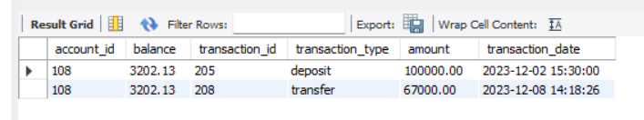

**7. Identify customers who have accounts of multiple types.**

select customer_id,first_name,last_name from customers where customer_id in (select customer_id from accounts group by customer_id having count(distinct(account_type))>1);

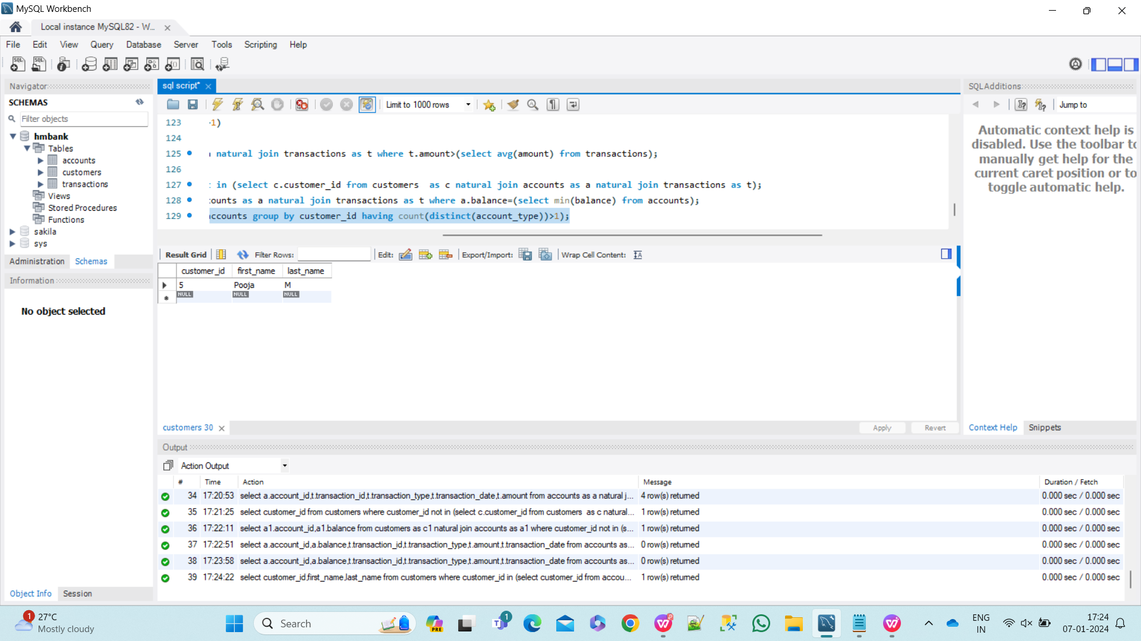

**8. Calculate the percentage of each account type out of the total number of accounts.**

SELECT account_type, COUNT(*) AS total_accounts,

(COUNT(*) * 100.0 / (SELECT COUNT(*) FROM Accounts)) AS percentage

FROM Accounts GROUP BY account_type;

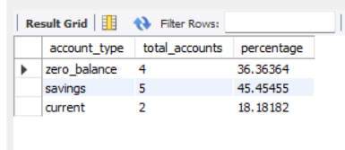

**9. Retrieve all transactions for a customer with a given customer_id.**

select account_id,transaction_id,transaction_type,amount,transaction_date from transactions where account_id in (select account_id from accounts where customer_id=5);

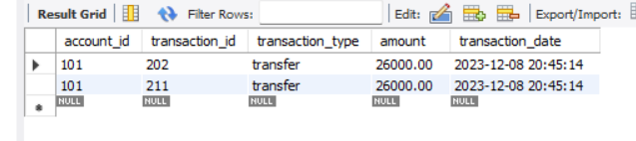

**10. Calculate the total balance for each account type, including a subquery within the SELECT clause.**

SELECT account_type, (SELECT SUM(balance) FROM Accounts a2 WHERE a2.account_type = a.account_type) AS total_balance

FROM Accounts a GROUP BY account_type;

